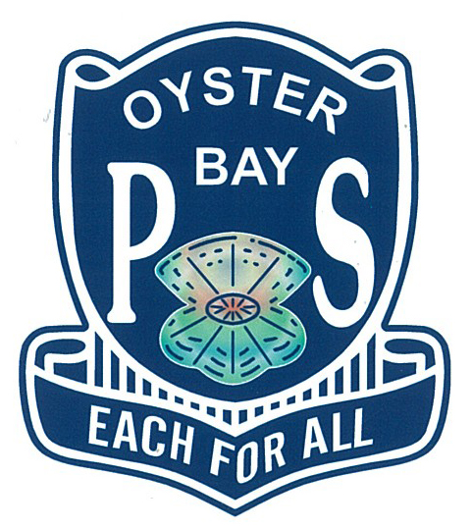 Oyster Bay Public School
2023 Anti Bullying Plan

Overview
Bullying behaviour has three key features. It involves the intentional misuse of power in a relationship. It is ongoing and repeated, and it involves behaviours that can cause harm. The NSW Department of Education requires all NSW Public Schools to have an Anti-bullying Plan which details the strategies implemented to reduce student bullying behaviours. Resources include the NSW anti-bullying website (see: https://antibullying.nsw.gov.au) provides evidence-based resources and information for schools, parents and carers, and students. Schools are encouraged to visit the website to support whole-school prevention, early intervention and response approaches and strategies for student bullying behaviour.

Oyster Bay Public School’s commitment

Our school rejects all forms of bullying behaviours, including online (or cyber) bullying by maintaining a commitment to providing a safe, inclusive and respectful learning community that promotes student wellbeing. Executive staff are committed to establishing evidence-based approaches and strategies that promote a positive climate where bullying is less likely to occur.

School Culture and inclusion

All members of the school community are active participants in building a welcoming school culture that values diversity and fosters positive relationships. A key component of a supportive school culture is building respectful relationships and an ethos that bullying is not accepted, in both online and offline environments. School staff will actively respond to student bullying behaviour. Our school engages in the following practices to promote a positive school culture.

Student communication
Expectations of student behaviour will be discussed and information presented to promote a positive school culture where bullying is not accepted at a variety of settings such as Celebration of Learning Assemblies, class meetings and within our PBL focus of our school values taught each term within the PDHPE lessons.

Staff communication

Staff will be supported with professional learning that provides evidence-based ways to encourage and teach positive social and emotional wellbeing and discourage, prevent, identify, and respond effectively to student bullying behaviour. Professional learning is provided to all staff each Wednesday afternoon after school from 3.30pm till 5pm. Topics include Inclusive, Engaging and Respectful Schools, MyPL webinars and support programs, Student Behaviour Strategy modules, expert teacher modelling and external providers providing professional learning to all staff.

New and Casual Staff

New and casual staff will be informed about our school’s approaches and strategies to prevent and respond to student bullying behaviour through our induction for all new teachers, through information provided by supervisors to all casual staff and also provided through casual folders with explicit individual class information.

Partnerships with families and community
Effective schools have high levels of parental and community involvement. This involvement is strongly related to improved student learning, attendance and behaviour. Our school proactively builds collaborative relationships with families and communities to create a shared understanding of how to support student learning, safety and wellbeing. With an active P&C, our school Parent Portal for all communication (direct and broadcasts and individualised parent meetings – this ensures a strong, powerful partnership exists at OBPS.

Website

Our school website has information to support families help their children to regulate their emotions and behaviour and develop socially. Information is provided to assist if children have been involved in bullying behaviour (as the person engaging in bullying behaviour, as the person being bullied or as the person witnessing the bullying behaviour).

Communication with parents

Our school will provide information to parents to help promote a positive school culture where bullying is not acceptable and to increase parent’s understanding of how our school addresses all forms of bullying behaviour.

Support for wellbeing and positive behaviours
Our school’s practices support student wellbeing and positive behaviour approaches that align with our school community’s needs. Social and emotional skills related to personal safety, resilience, help-seeking and protective behaviours are explicitly taught across the curriculum in Personal Development, Health and Physical Education (PDHPE).

Reviewing dates 12.12.2023
Last review date: 28.02.2023
Next review date: 18.12.2023

